WMRHS junior wins Essay Award
By Jay Perreault

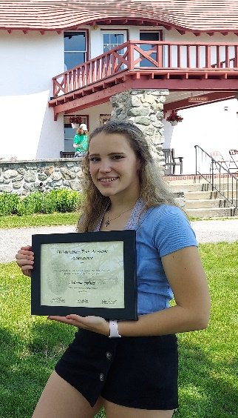
Lancaster’s, Adrienne Foster, recently won first prize in the Weeks State Park Association’s first-ever Essay Award project. Sally Pratt, President of the WSPA, explained. “We’ve been looking for ways to make connections with our young people, to get them more involved with our park.”
At a WSPA Board meeting in the spring, Membership Chair, Janet Wittenauer, suggested that an essay writing project might provide an opportunity for students to become more engaged and the Board enthusiastically agreed.
There were two major hurdles to overcome in order to implement the project this school year – time constraints, as it was already March, and the COVID pandemic. Vice-President, Jay Perreault said: “My brother is a retired professor who taught Educational Leadership. He trained future Principals and Superintendents. He told me: ‘a good Principal, and good Teachers are always looking for opportunities to connect their students with the community and engage them in those types of projects – but with COVID, that could be a serious challenge.’”
Fortunately, under Jacob Hess’ leadership, the staff at WRMHS encouraged the project with their students. One teacher in particular, Molly Campbell, seized on this opportunity and was able to incorporate the project into her Junior Seminar class.

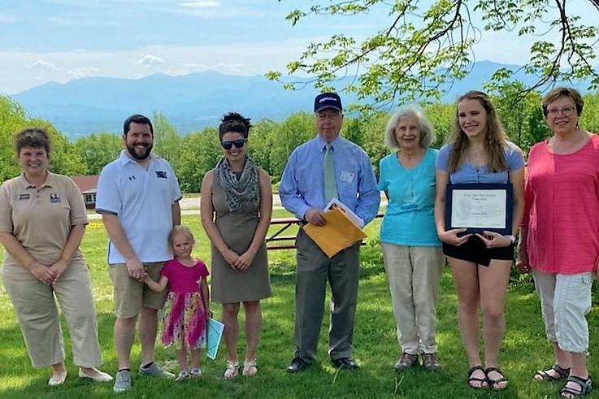
Left to right: Rachel Bruce - WSP Park Manager, Jacob Hess (with daughter) – Principal WMRHS, Molly Campbell -Junior Seminar Teacher, Jay Perreault - VP WSPA, Sally Pratt – President WSPA, Adrienne Foster, Janet Wittenauer - Membership Chair WSPA
On Saturday, June 5, at Weeks State Park, Adrienne was presented the Award for 1st prize, a check for $150 and copies of her essay which have been published in the WSPA’s newsletter “In Prospect.” Congratulations to Adrienne and thank you to the WMRHS staff & students.

